Case 6-Afr-Burkina Faso-Dwo Mask-Bobo People-early 20th c

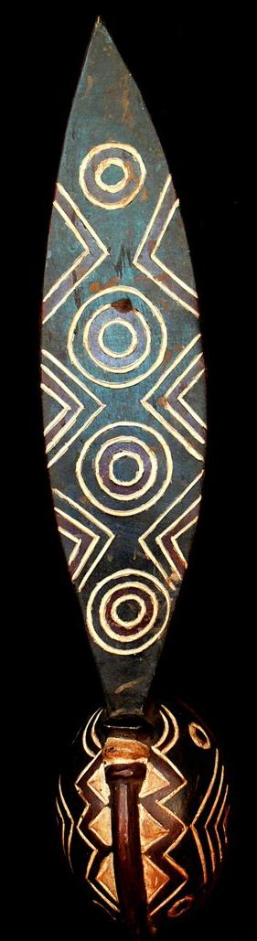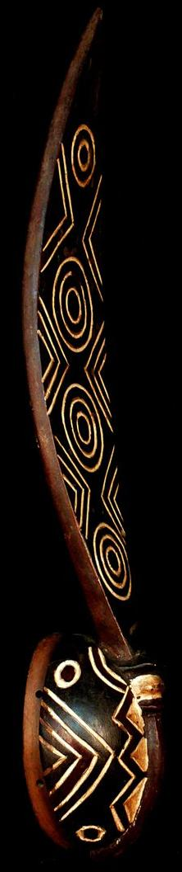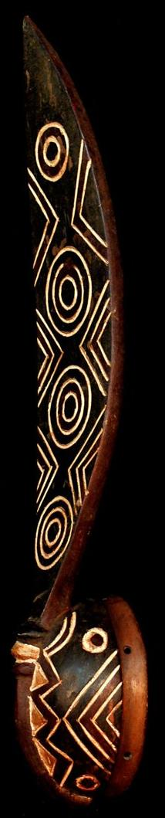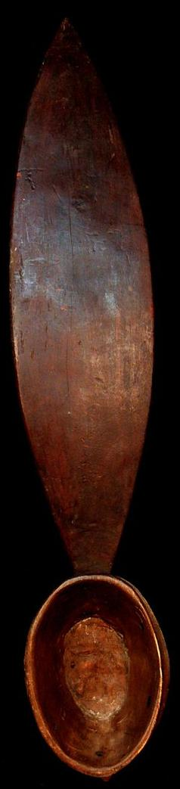

|  |  |
| --- | --- |
|  |  |

Case No.: 6

Accession Number:

Formal Label: Afr-Burkina Faso-Nwenka Mask-Bobo-Fing People-mid 20th c

**Display Description:**

This Nwenka mask is one of the oldest and most sacred wooden masks of the true Bobo-Fing ("black Bobo"), who speak Bobo, a Mande language, who live in the area of Bobo-Dioulasso, Burkina Faso. Mande languages have a time horizon of 7000 years BP, on the very furthest range of what lexico-statistics can determine (Greenberg 1966). Then its speakers were a Neolithic culture, as indicated by the Proto-Niger-Congo words. As the Neolithic Bobo-Fing People technologically advanced into the copper-smelting age of the Chacolithic, it is proposed that masks that enact the creation of the world by Wuro (an aniconic deity) were first developed. Tradition maintains that they date from the time of creation, which would be the time horizon of the divergence of the Mande languages. This is traditionally believed when Wuro, the Creator, molded the world and beings to inhabit it from moist (unfired) clay. Then Wuro created Blacksmith and his Potter Wife (Koloss 2002). Blacksmith was considered a powerful personage since he was able to smelt metal, while his wife was also considered powerful since she could fire pottery, which until then had been unfired. Thus, both were powerful for they could use fire, a magical energy, for recondite purposes unknown to the common people.

Then Wuro retreated from the Chacolithic world he had created. He left his three sons to manage people in maintaining a balance between opposing forces. His most important son is Dwo, who wears a forest mask, which Wuro originally fashioned out of leaves, recalling the primordial hunter-gatherer, forest life of the Bobo people before they knew fire. This mask invokes the being of Dwo, the intermediary spiritual being through whom people could communicate with the Creator God, Wuro. Wuro, in turn, gave Dwo’s mask to the blacksmith who carved it of wood in the old way before metalsmithing was known when the life of the Bobo People was encompassed by the primordial forest. Blacksmith also carved other mask versions of Dwo to manifest Dwo's many faceted aspects. Nwenke masks (sing. Nwenka) of Dwo are carved in the form of a helmet featuring a prominent forehead, circular eyes, a long, narrow nose, and are surmounted by a vertical frontal plank in the shape of a giant leaf with side serrations and with concentric circles suggesting rain drop patterns on water. Nwenke masks are traditionally painted red, white, and black are worn by an elder who is concealed by a raffia fiber costume who dances to a ceremonial choreography, an accompanying percussionist plays an instrument that sounds much like a xylophone, which is constructed of wood slats of graduated lengths fastened tightly together with a fiber cord (Coffman 1992).

LC Classification: [PL8005](https://library.simmons.edu/search~S0?/cPL8005+.G7+1970/cpl+8005+g7+1970/-3,-1,,E/browse)

Date or Time Horizon: 6000 BP

Geographical Area: Burkina Faso

Map:

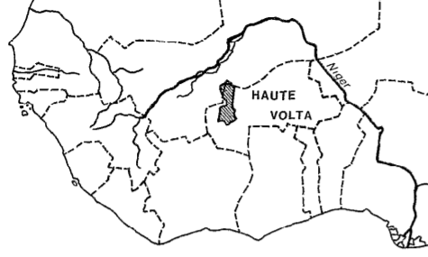

Location of the Bobo People (after Le Moal 1980).

GPS Coordinates:

Cultural Affiliation: Bobo People

Medium: Wood and kaolin pigment

**Dimensions**: H 27.559 inches  
**Weight:** 1.303 lbs

**Provenance**: Burkina Faso

**Condition:**

**Discussion:**

**References:**

Coffman, R. J., 1992. Burkina Faso Notebooks. MS.

Greenberg, Joseph H., 1966. *The Languages of Africa* (2nd ed. with additions and corrections). Bloomington: Indiana University.

Koloss, H.J. ed., 2002. *Africa: Art and Culture: Masterpieces of African Art, Ethnological Museum, Berlin* (Vol. 1). Prestel Pub.

Le Moal, G., 1980. *Les Bobo: nature et fonction des masques*. Paris Orstrom.

Roy, C.D. and Chaffin, A., 1987. *Art of the Upper Volta rivers*. Meudon: A. et F. Chaffin